Andrew Mann

11/20/2022

Foundations of Python

Assignment 06

Introduction:

The focus of module 6 was on functions and classes. I was familiar with functions from my experience with MATLAB however, “classes” was a new topic to me. There were a few new things that I learned about functions in Python that were new to me. I thought it was really interesting how python will allow you to set default parameters for functions, which I am still not quite sure why that would be useful in practice. Additionally, that the variables within a function are localized to that function and are different than a variable of the same name outside of the loop, I feel like this helps consolidate the different variable names in a script.

The classes confused me a little on what their specific advantage or use was. I used this [website](https://www.geeksforgeeks.org/python-classes-and-objects/) and this [2nd](https://www.hackerearth.com/practice/python/object-oriented-programming/classes-and-objects-i/tutorial/) one to get another explanation of what classes were. From what I understand they "blueprints” to create objects with attributes. Best analogy I could think of was like character selection in the beginning of a video game, with each function in a class being some sort of attribute you can change for your character. The object is the different characters that the class can create.

For the assignment I expanded on the three existing classes that were created. I added a function to delete inventory in the DataProcessor class. In the FileProcessor class I added a function to write data from 2D table to file. In the IO class I added the function to take in user input. I revisited for loops to look at the different ways to assure the loops would delete all positions for the row chosen and break when done. This was one of the websites I used to help with some review of for [loops.](https://www.geeksforgeeks.org/iterate-over-a-list-in-python/)

See Screen shots below of program running!

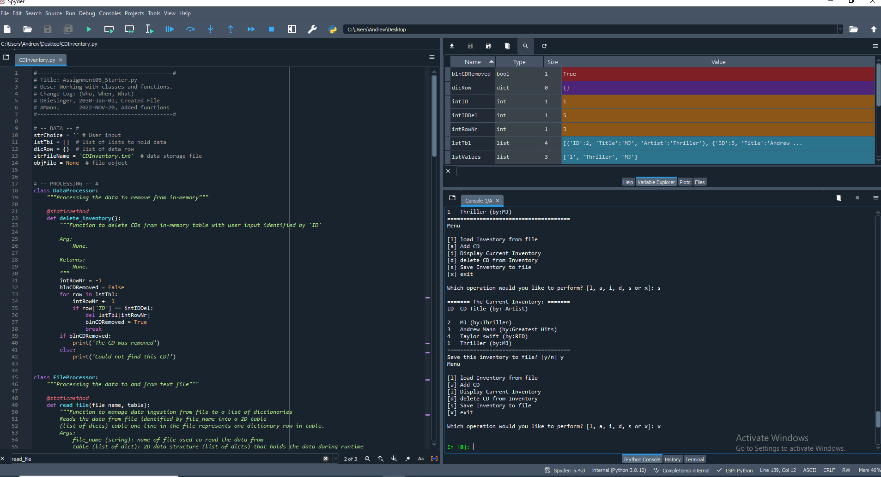

Figure 1: Code running in Spyder